**Exercise: Highlighting key information**

**Introduction**

By now, you should have gained a solid grasp of essential concepts such as knowing the audience, age-related design, and prioritizing key information. These fundamental principles converge to establish the framework for formatting and creating impactful reports in Microsoft Power BI. This exercise gives you the opportunity to apply your knowledge in a Power BI end-to-end scenario using the techniques that you learned.

**Scenario**

You are working as a data analyst at Adventure Works. You have sales data that contains target versus sales by category in the file *AdventureWorksSalesvsTarget-Category.xlsx*.

Your manager, Adio Quinn, has assigned you the task of creating a report that shows the detailed list of the yearly target versus sales by category and also puts the figures in a column chart report by emphasizing the top sales amounts. Your objective is to create the report in a good format and highlight the key data.

* This exercise aims to help you to format and highlight key data in a Power BI Report.
* By the end of this exercise, in a Power BI Report, you’ll understand how to use table and column chart visualization tools, apply a theme, change the color of particular data points, add color to table rows, and apply conditional formatting to highlight key data.

**Step 1: Download the Excel files**

1. Create a new Power BI project called *Exercise – Highlighting key information.pbix.*
2. Download the *AdventureWorksSalesTarget-Category.xlsx****,*** and *AdventureWorksLogo.png* files, which you will use in this exercise. You can download the Adventure Works logo by selecting the logo and downloading it.

[AdventureWorksSalesTarget-Category](https://d3c33hcgiwev3.cloudfront.net/RPc-KFm0T26HERJJxZdBkA_c5146c0fb3f04714bdfbc8bae18e47e1_AdventureWorksSalesTarget-Category--C6M1L3-Item-5-7.xlsx?Expires=1712188800&Signature=Tm3euoQPcaJoQrT8b~TpNWGI1-0Afjc~Rk6J42fEOuuNipaTnTADSH4AZV9SaOR4LkV0GarWjDI8uskVPIyNfVuIMyje9006ggeSL7tuNAismeaojFTrd34JhuCSy-pCP7cAq0nsrPZzfM0zNxWgn1f7TIttQ~Irxhn9wAxHYr8_&Key-Pair-Id=APKAJLTNE6QMUY6HBC5A" \t "_blank)

[XLSX File](https://d3c33hcgiwev3.cloudfront.net/RPc-KFm0T26HERJJxZdBkA_c5146c0fb3f04714bdfbc8bae18e47e1_AdventureWorksSalesTarget-Category--C6M1L3-Item-5-7.xlsx?Expires=1712188800&Signature=Tm3euoQPcaJoQrT8b~TpNWGI1-0Afjc~Rk6J42fEOuuNipaTnTADSH4AZV9SaOR4LkV0GarWjDI8uskVPIyNfVuIMyje9006ggeSL7tuNAismeaojFTrd34JhuCSy-pCP7cAq0nsrPZzfM0zNxWgn1f7TIttQ~Irxhn9wAxHYr8_&Key-Pair-Id=APKAJLTNE6QMUY6HBC5A" \t "_blank)



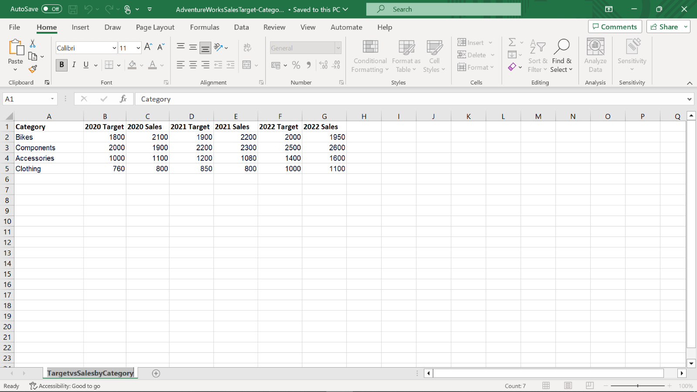

**Step 2: Open the Power Query Editor**

1. Choose **Get Data** in Power BI.
2. Select **Load,** and import your dataset, **TargetvsSalesbyCategory**.

**Step 3: Design the Report Layout**

1. Add a table that contains **Category**, **2020Target**, **2020Sales**, **2021Target**, **2021Sales**, **2022Target**, and **2022Sales**fields from the **TargetvsSalesbyCategory** table.
2. Add a **column chart** below the table, that consists of **Category**, **2022Target**, and **2022Sales** fields from the **TargetvsSalesbyCategory** table.
3. Align the table and column chart **vertically**.
4. Add the company logo, by selecting the *AdventureWorksLogo.jpg*  file from its saved file location**.** Drag the logo to position it at the **top-left corner**, and also drag the guide markers to resize the logo to any size that fits well in the design.
5. Rename the report as **Sales Target Report**.
6. Now you have two visualization elements, table and chart, with a consistent positioning and alignment.

**Step 4: Apply formatting styles**

1. Set the title of the table as **Sales vs. Target by Category Details**.
2. Set the chart title as **Sales vs. Target by Category Chart Report**.
3. Remove the **Sum of** prefix from all the column names.
4. Apply a **report theme** and select **Accessible City Park** as the theme. In this way, all visuals in your report use the colors and formatting from this theme.

**Step 5: Highlight key data with conditional formatting**

* Highlight the top sales amounts by applying conditional formatting, and show the top sales amounts in the **Sales 2022** column by setting font color to color code **#f1c4cc** for the minimum value and color code **#6f3640** for the maximum value.

**Step 6: Change the color of a single data point and all data points**

You need to highlight the **2022 Sales** values to show how well the sales are performing, by using color. To do that:

1. Expand the **Columns** card and turn on **Show all** to display the colors for each data element. You can now modify any of the data points.
2. Find **2022 Sales** and apply color code **#AD8F21**.

**Conclusion**

By following these steps, you can improve your report design quality and keep a visual cohesiveness that effectively communicates information for Adventure Works.

You have now successfully completed a cohesive report design by formatting and highlighting key data in a Microsoft Power BI Report.

**Exemplar: Highlighting key information**

**Introduction**

In the exercise *Highlighting key information,* you put into practice your understanding of how to prioritize key information in Microsoft Power BI.

This exercise included tasks to:

* Apply formatting styles.
* Highlight key data with conditional formatting.
* Change the color of a single data point or all data points.

This reading provides a step-by-step guide to completing these tasks, accompanied by screenshots for easy comparison with your own work.

**Step 1: Download the files**



[AdventureWorksSalesTarget-Category](https://d3c33hcgiwev3.cloudfront.net/RPc-KFm0T26HERJJxZdBkA_c5146c0fb3f04714bdfbc8bae18e47e1_AdventureWorksSalesTarget-Category--C6M1L3-Item-5-7.xlsx?Expires=1712188800&Signature=Tm3euoQPcaJoQrT8b~TpNWGI1-0Afjc~Rk6J42fEOuuNipaTnTADSH4AZV9SaOR4LkV0GarWjDI8uskVPIyNfVuIMyje9006ggeSL7tuNAismeaojFTrd34JhuCSy-pCP7cAq0nsrPZzfM0zNxWgn1f7TIttQ~Irxhn9wAxHYr8_&Key-Pair-Id=APKAJLTNE6QMUY6HBC5A" \t "_blank)

[XLSX File](https://d3c33hcgiwev3.cloudfront.net/RPc-KFm0T26HERJJxZdBkA_c5146c0fb3f04714bdfbc8bae18e47e1_AdventureWorksSalesTarget-Category--C6M1L3-Item-5-7.xlsx?Expires=1712188800&Signature=Tm3euoQPcaJoQrT8b~TpNWGI1-0Afjc~Rk6J42fEOuuNipaTnTADSH4AZV9SaOR4LkV0GarWjDI8uskVPIyNfVuIMyje9006ggeSL7tuNAismeaojFTrd34JhuCSy-pCP7cAq0nsrPZzfM0zNxWgn1f7TIttQ~Irxhn9wAxHYr8_&Key-Pair-Id=APKAJLTNE6QMUY6HBC5A" \t "_blank)

1. You created a new Power BI project called *Exercise – Highlighting key information.pbix.*
2. Then you downloaded the *AdventureWorksLogo.png* file and the *AdventureWorksSalesTarget-Category.xlsx* file, for use in the exercise.

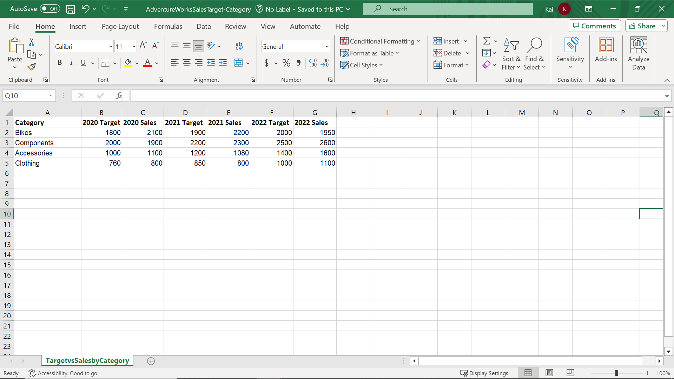

**Step 2: Open the Power Query editor**

1. You selected **Get Data** in Power BI.
2. Then selected **Load,** and imported your dataset, *TargetvsSalesbyCategory*.

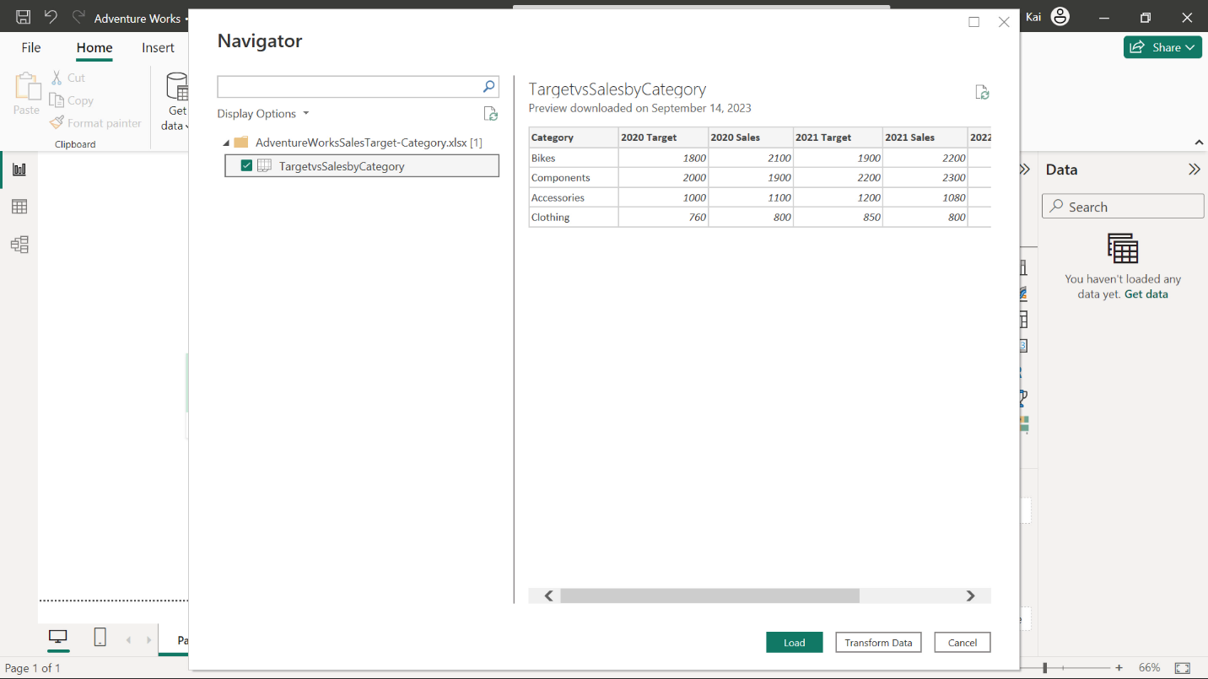

**Step 3: Design the report layout**

1. You then added a table that contains the fields; **Category**, **2020 Target**, **2020 Sales**, **2021 Target**, **2021 Sales**, **2022 Target**, and **2022 Sales** from the **TargetvsSalesbyCategory** table.

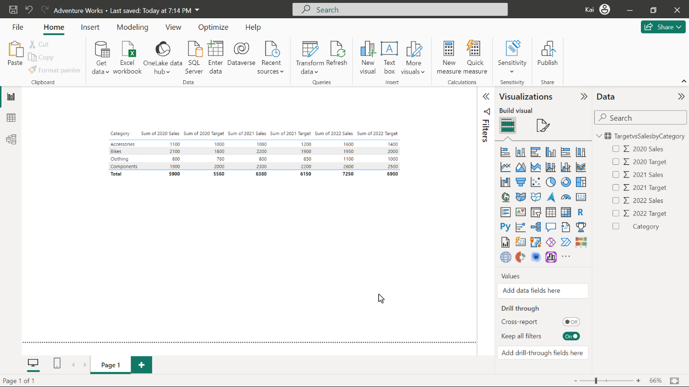

1. You added a column chart below the table, that had **Category**, **2022 Target**, and **2022 Sales** fields from the **TargetvsSalesbyCategory** table.
2. You vertically aligned the table and column chart.

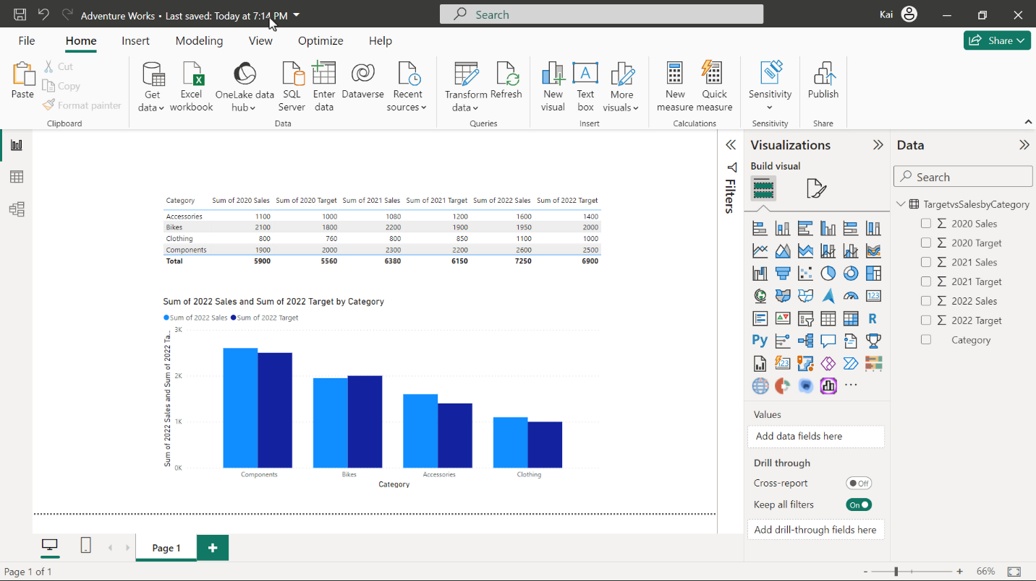

1. You added the Adventure Works company logo, by selecting the *AdventureWorksLogo.png* file from its saved file location. You dragged the logo to its position at the top-left corner, and also resized the logo using the guide markers.
2. You changed the report's name to **Sales Target Report**.

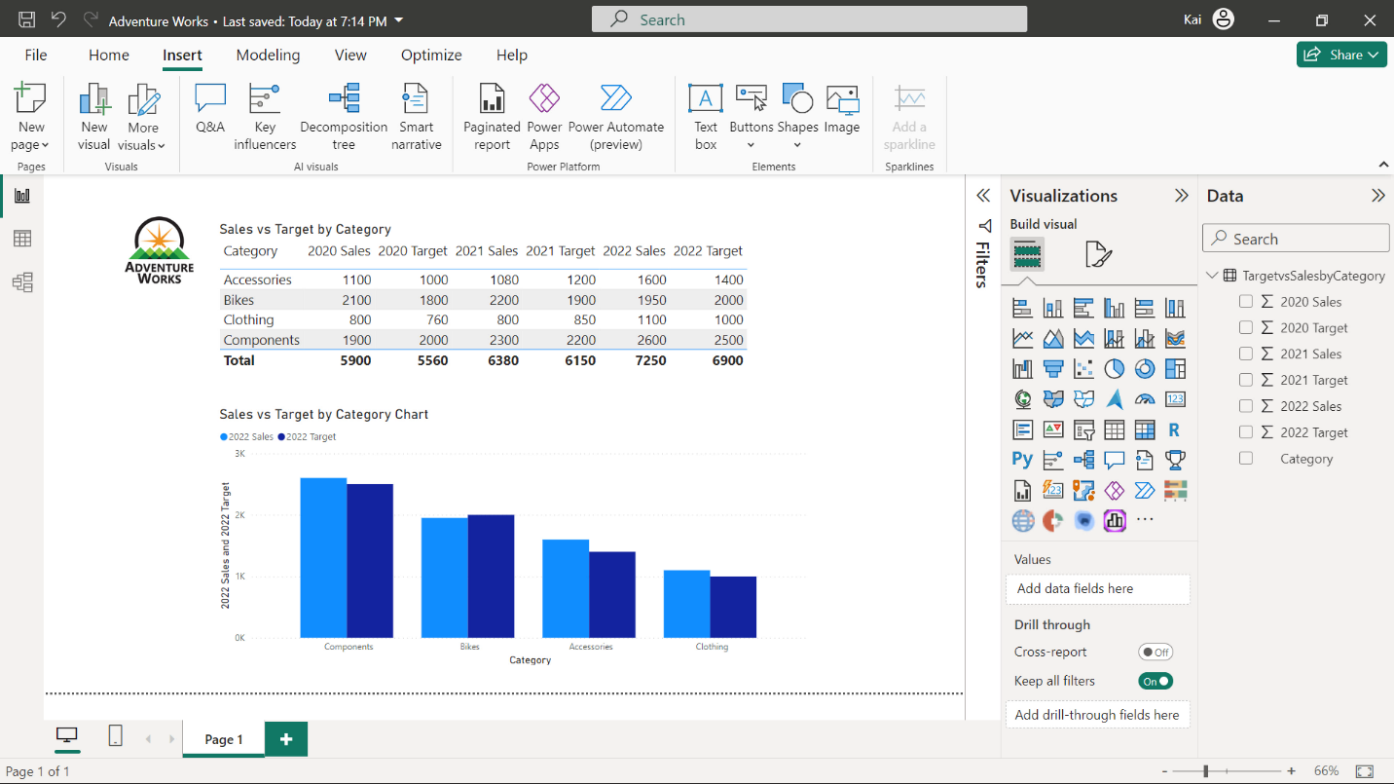

At the end of this part of the exercise you had two visualization elements, a table and a chart, and had them in a consistent positioning and alignment.

**Step 4: Apply formatting styles**

1. You set the title of the table as **Sales vs. Target by Category**.
2. You set the chart title as **Sales vs. Target by Category Chart**.
3. You then removed the **Sum of** prefix from all the column names.
4. You also applied a report **theme** and selected **Accessible City Park** as the theme. Now, all visuals in your report use the colors and formatting from this theme.

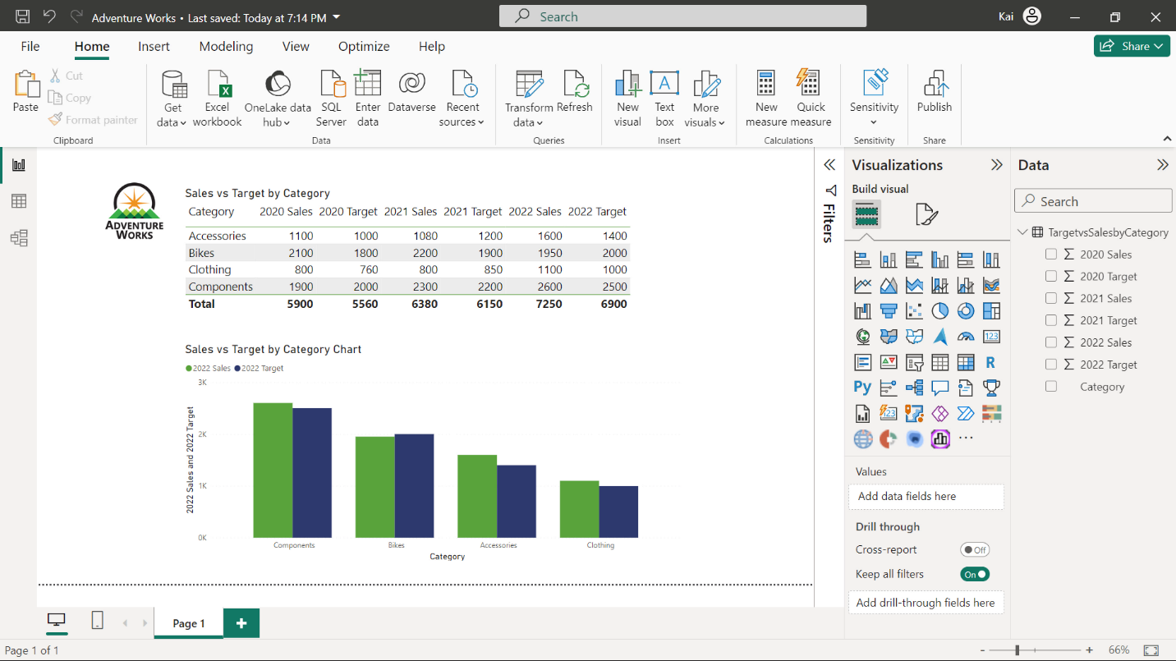

**Step 5: Highlight key data with conditional formatting**

1. You highlighted the top sales amounts by applying conditional formatting and displayed top sales amounts in the **Sales 2022** column by setting the font color to a red theme color (theme color 4) for the minimum value and to a blue theme color (theme color 2) for the maximum value. To begin this process, you selected **Conditional Formatting**. To apply the conditional formatting, you selected the table and then navigated to **Visualizations > Build visual > Columns**.

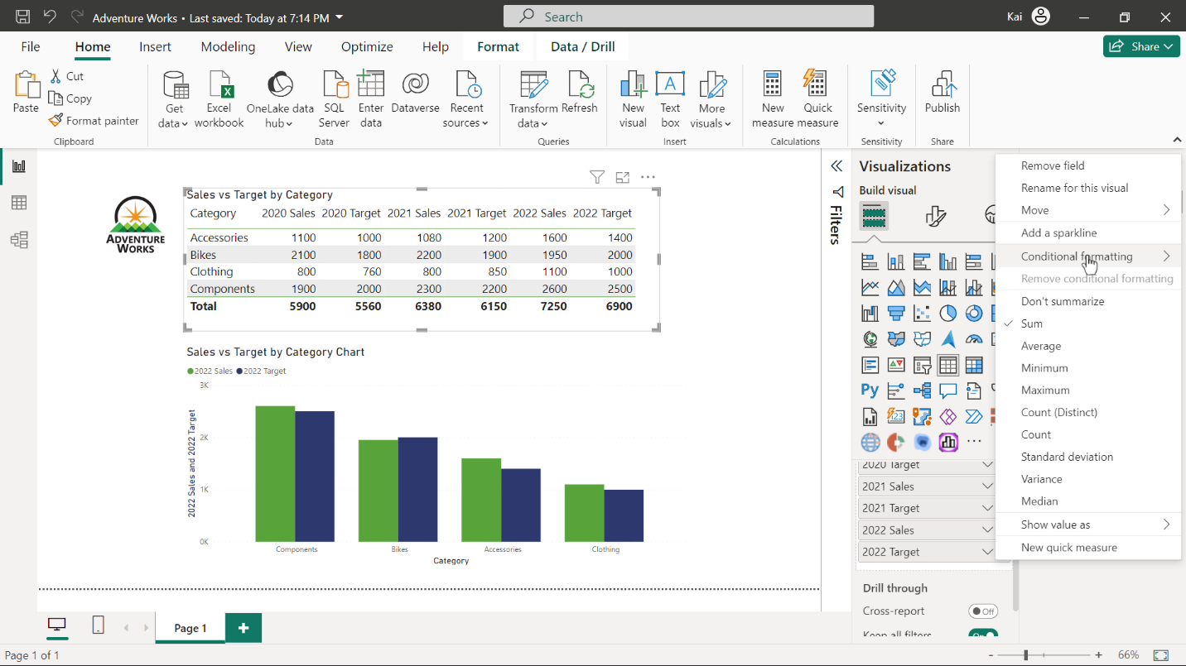

You selected the down arrow near the **2022 Sales** column and in the **Conditional Formatting** menu selected **Font Color**. Then you selected **Gradient** in the **Format Style** dropdown, and retained the other default values.

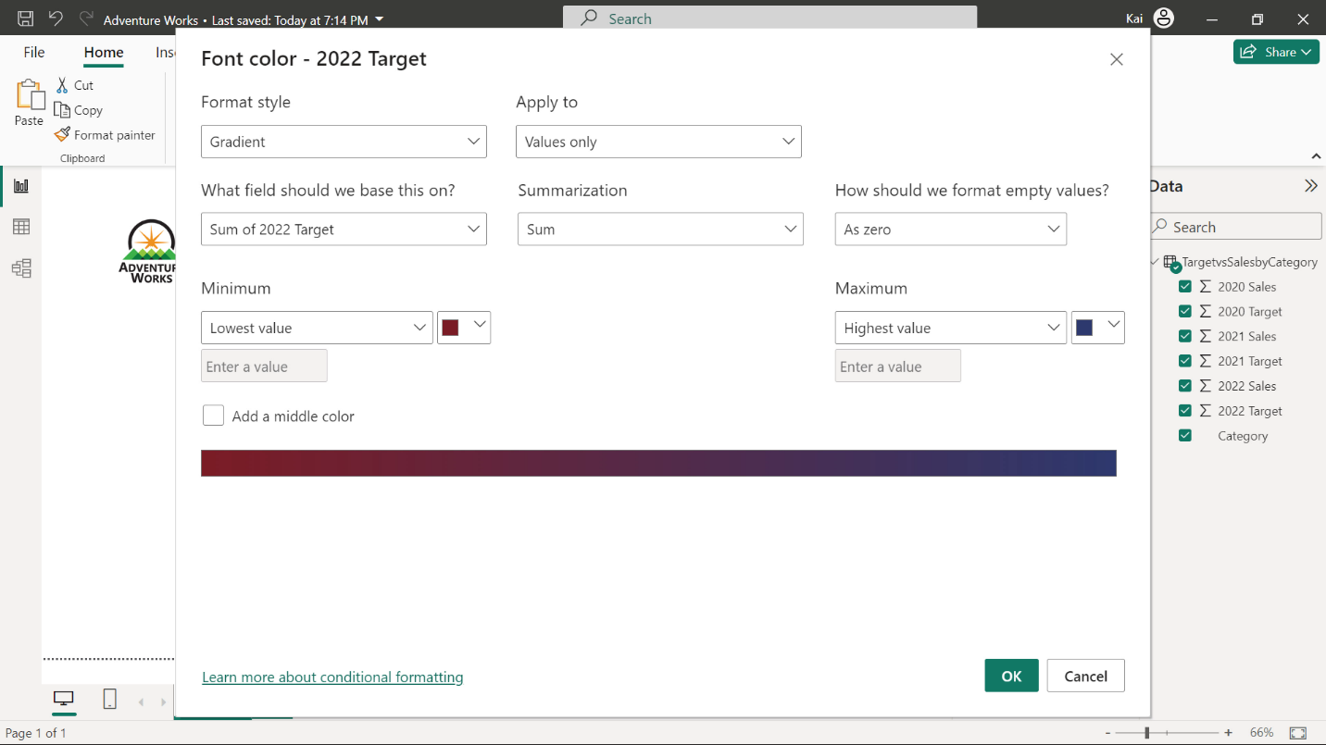

**Step 6: Change the color of a single data point or all data points**

1. You needed to highlight the **2022 Sales** values to show how well the sales are performing, using color. To do that: you expanded the **Columns** card and enabled **Show all** to display the colors for each data element. You then modified the data points.
2. To adjust **2022 Sales,** you navigated to **Visualizations > Format visual > Visual > Columns,** there you found **2022 Sales** and applied the yellow theme color (theme color 3).

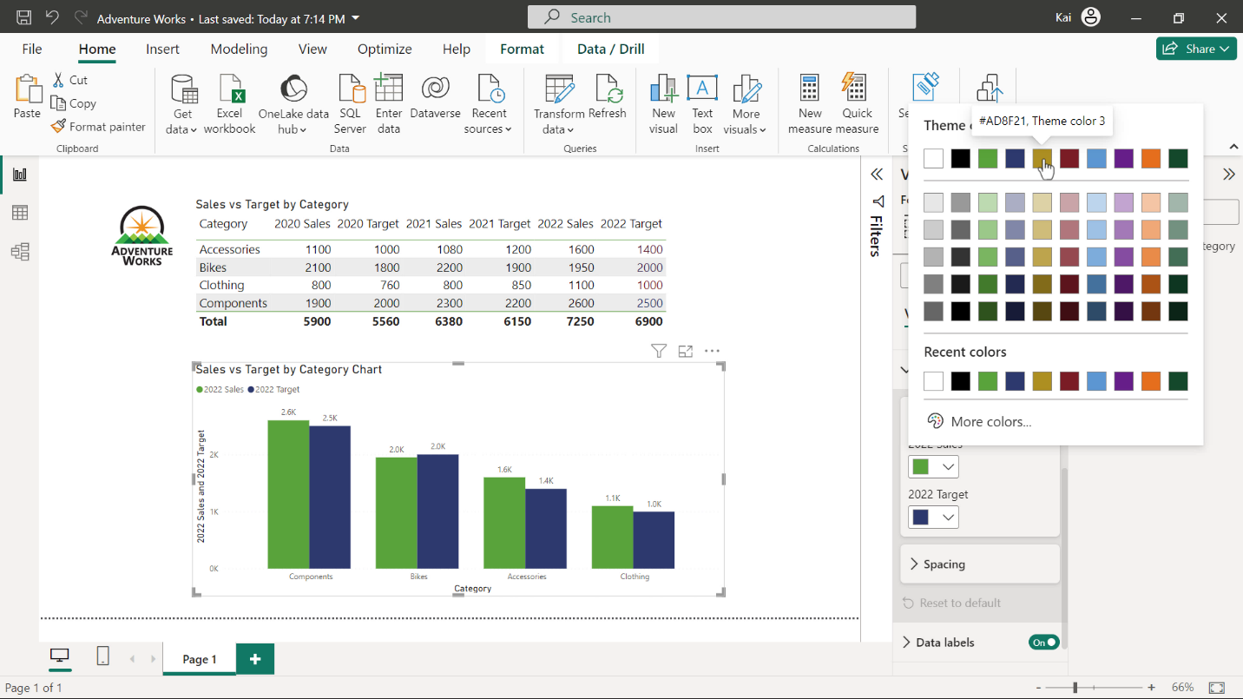

**Tip:** You can experiment with your design by changing the color of a data point for one, several, or all data elements in the visualization. Try choosing the Adventure Works corporate colors of green, orange, and blue as seen in the logo of the *AdventureWorksLogo.png* file.

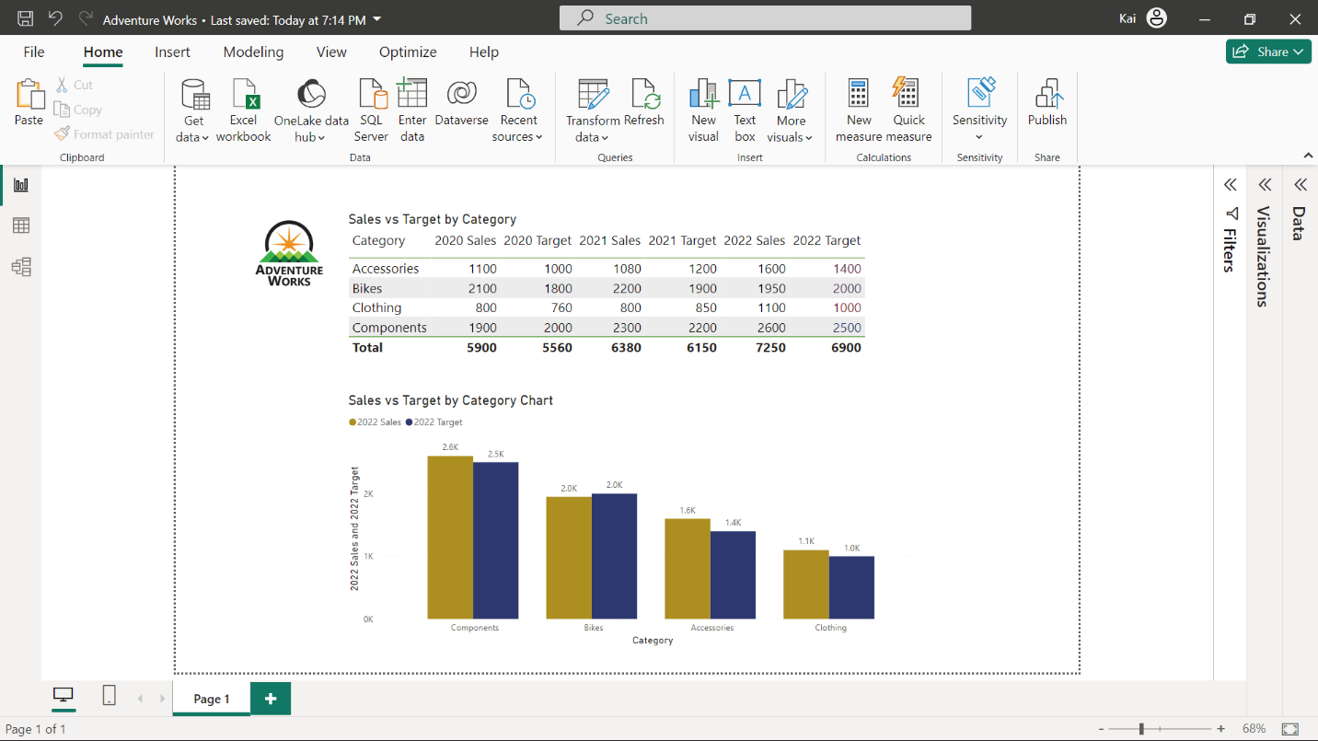

**Conclusion**

When you finish creating a report, you will often continue the design process to refine and iterate the design. Steps to consider are:

* Review the redesigned page and make any necessary adjustments or improvements.
* Seek feedback from colleagues or users to validate the effectiveness of your design.
* Continuously refine and iterate the page based on feedback and evolving needs.

By following these steps, you can improve your report design quality and keep its visual cohesiveness that effectively communicates information for Adventure Works.

Your objective for this exercise was to complete an end-to-end scenario by prioritizing key information. In this context, you learned how to design a report by the formatting and highlighting of key data in Microsoft Power BI.